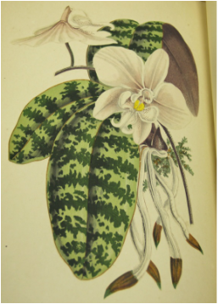
April showers bring May flowers! The James Smith Noel Collection at LSUS is presenting an exhibit titled “Nature’s Beauty: Exploring Plants and Flowers and Their Uses.” The materials on display will tell the tale of mankind’s interactions with nature, from agriculture to amateur gardening. We invite you to trace the growth of botany as its own science and the flourishing of landscape gardening as knowledge was shared across continents. Step inside the collection to view some of our rarest materials, including a flower arranging game from the 1860s and a collection of hand-colored botanical prints from the 1700s.

All of these materials have been drawn from a special collection of 250,000 volumes, descriptions of which are being added daily to the LSUS online library catalog. This astonishing variety of rare and popular materials was collected by James Smith Noel and is now housed on the third floor of the Noel Memorial Library at LSUS.

Come visit us in the Noel Collection to explore and learn more!

The exhibit will run from May through July and is open Monday-Friday from 8:00 a.m.-4:30 p.m. For more information or to arrange a tour contact Martha Lawler at 318-798-4163 or Martha.Lawler@lsus.edu.

